Manitoba Immunization Verification Job Aid
Commissionaires Manitoba has been approached by the province to provide Immunization Verification for staff and volunteers at various municipal public buildings, in particular community centres such as hockey arenas. While the current requests are for hockey arenas, it is anticipated that as the municipalities open further some of these requests may include other public areas such as libraries or curling rinks.
To assist with the verification process, it is critical that each municipality inform the public of the requirement which must also include putting signs up on the exterior doors prior to entry into the building. Samples are below:
- Masks must be worn inside the public building.
- Social distancing must be maintained
- Proof of Vaccination required for entry
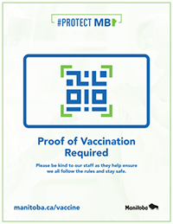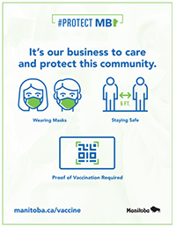
Please note both (along with others) are downloadable from the Province of Manitoba Shared Health site:
https://www.gov.mb.ca/covid19/updates/resources.html

TASKING REMINDERS
For members of Commissionaires Manitoba should you be tasked with providing immunization verification please remember having exceptional customer service skills should always be your first point of contact for all interactions with the public.
Immunization verification can be a sensitive issue for some people, so how we approach the individual becomes key to how well the request is received.
GREETINGS:
Good morning/afternoon/evening always serves to break the ice along with making friendly eye contact.
“Good morning, how are you today? May I see your immunization card and a valid government issued photo ID please?”
What are valid government issued photo ID? Any photo that has been issued by the Province of Manitoba or Government of Canada that includes a photo, date of birth, and full name. In Manitoba acceptable forms of photo ID are as follows:
- MB Driver’s License
- MB Provincial ID Card (please note, the MB Enhanced ID card is no longer valid as of June 1, 2022, and holders should have applied for a new ID card to be reissued prior to this).
- Canadian Passport
- Certificate of Indian Status card
- Permanent Residence Card
- Canadian Forces Identification Card or Veteran Service Card
SCANNING THE QR CODE
After the Manitoba Immunization Verification APP has been downloaded onto the phone, touch the ICON and log into the account using the credentials supplied. Please note, while you can use your own credentials to log in, this app DOES NOT track anything on the phone or against your account. No personal information is stored or is accessible when using the app. The log in information is simply used to access the app which reads the QR CODE.
Once you have opened the application, you will see the camera has been activated and a square for scanning the QR code has appeared.
Position the camera over the QR CODE (found on the rear of the immunization card or on the photo of the QR code presented) and press “VERIFY IMMUNIZATION”.
The screen will either change to GREEN with a checkmark and the individuals name will appear or will change to RED and an X will appear without a name.
A green checkmark showing the name is when you MUST validate the name against the VALID GOVERNMENT ISSUED PHOTO ID presented.
Once you have verified that the immunization code is valid and the person presenting the ID is the same person, they are cleared to go into the public area.
THANKING THEM
Just as important as your greeting, is when you thank them for their time. Sincerity and friendliness are always a game changer.
FORMS OF VALID GOVERNMENT ISSUED ID INCLUDE

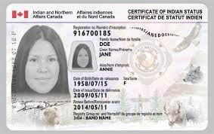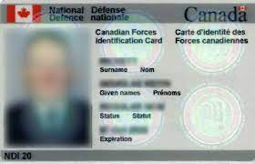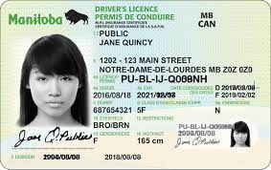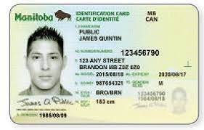
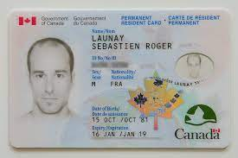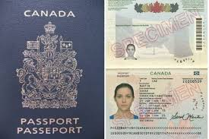

- Who needs to have proof of vaccinations?
In accordance with the public health orders everyone who is 12 and over, must be fully vaccinated to enter an indoor sporting facility.
- What do I need to do the verification?
The first step is to download the free Manitoba Immunization Verifier App from the Apple Itunes store or Google Play onto your phone.
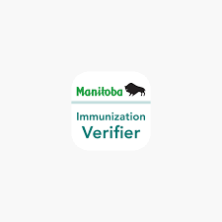
- How do I access it?
Using the creditials provided, log into the system and the following sceen will appear.
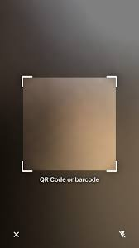

- Center the QR code square over the QR CODE found on the rear of the immunization card or photo of the QR code press “VERIFY IMMUNIZATION” located at the bottom (blue bar).
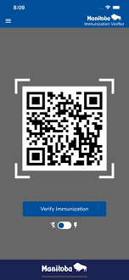
- How will I know if the QR CODE is valid?
A valid QR code will change the colour of the screen to GREEN and the indivudals NAME will show along with a checkmark. Once the green screen and individuals NAME has appeared, verify their VALID PHOTO ID presented.
An invalid QR code will show an X and the colour of the screen will change to RED.
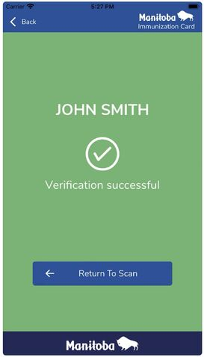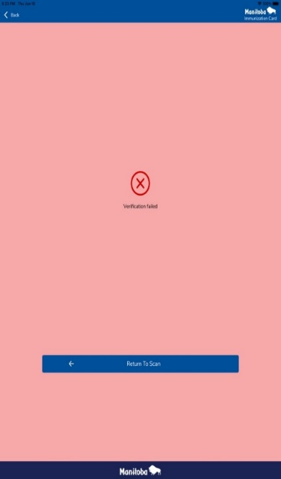
- What happens if the QR code comes up RED, indicating the individual has not been vaccinated.
Please ask them to politely leave. IF they refuse say,”Unfortunatly the public health orders dictate that you are not allowed into the facilitiy. I would ask that you leave the premises”
- What happens if the person refuses to leave or becomes threatening or abusive towards me?
IF someone becomes threatening or abusive and refuses to leave, contact the local police or RCMP.
IF the person has already gained entry into the facility, take note of their appearance, what they are wearing, make, model & colour of vehicle (If known) as well as any other information that may be critical for identifying the individual and contact the police or RCMP citing the individual is in violation of the public health orders and in violation of the Petty Tresspass Act.
- What if the individual is from another province, country or is a member of the Canadian Armed Forces?
The Canadian Armed Forces have been given a ‘card’ specifying their vaccination dates (sample below):
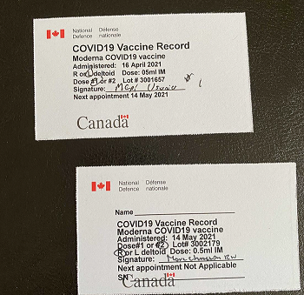

Each province has also produced documents citing the individuals vaccination status (SEE SAMPLE PAPER COPIES - APPENDIX A); NOTE: While some may have ‘verification QR codes’ they may not be compatible with our PROIVINCAIL APP, so anyone from outside the province must be able to provide alternate proof of vaccination. Appendix A shows samples from each province.
Other countries have also issued their own versions of documents or cards citing verification status. Care will need to be taken to ensure the docuements look valid and not altered in any way. Since we don’t have a copy of every document, it will remain up to the municipailtiy or arena/location to determine what is the approriate documentation that an out of country ‘team’ or visitors must produce.

The Canadian Government has also issued the CANADIAN COVID-19 VACCINATION RECORD (see image below) which also has the vaccinations listed as well as the province the vaccinations were received in. It is anticipated that the bar code will be able to be scanned at some point, however, it is not recognized electronically at this time (NOV 25, 2021). A VISUAL verification of this record is sufficient to determine vaccine status.
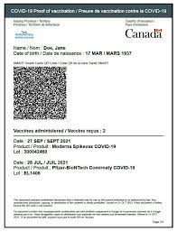
- What if the person says they are fully immunized but don’t have their QR CODE:
If they are from Manitoba, individuals should go into the shared health website listed below and either register online where they will be able to access their QR code. Once they log into the site, their QR code will appear and they can take a photo of it or screenshot it to save the code. This code will work the same way as the QR code on the rear of the immunization card.
To access the QR CODE they can go to https://immunizationcard.manitoba.ca or ask the individual to type in their search engine (google/safari etc) PROVINCE OF MANITOBA COVID 19 IMMUNIZATION CARD.
NOTE: the individual must first have a sharedhealth account. This is done by registering through the following link: https://sharedhealthmb.ca/covid19/test-results/
If they are from outside MANITOBA, they must produce a copy of their vaccination status. (see appendix A for samples of proof of verification from outside Manitoba.
- What if the person only has a photo of their QR code? Can I scan it instead?
Yes, however remember all QR codes must be confirmed with the name that appears against the provided valid photo ID.

On DECEMBER 6, 2021 all persons who are at least 12 years of age but who have not yet reached 18 years of age must produce proof that they have received one dose of the Pfizer-BioNTech or Moderna vaccine for COVID-19 OR have proof of a negative rapid COVID – 19 test within the previous 72 hours that is confirmed by a pharmacist. The sample below is from Shoppers Drug Mart however any pharmacy issuing it will have their logo and similar (if not the same information listed).

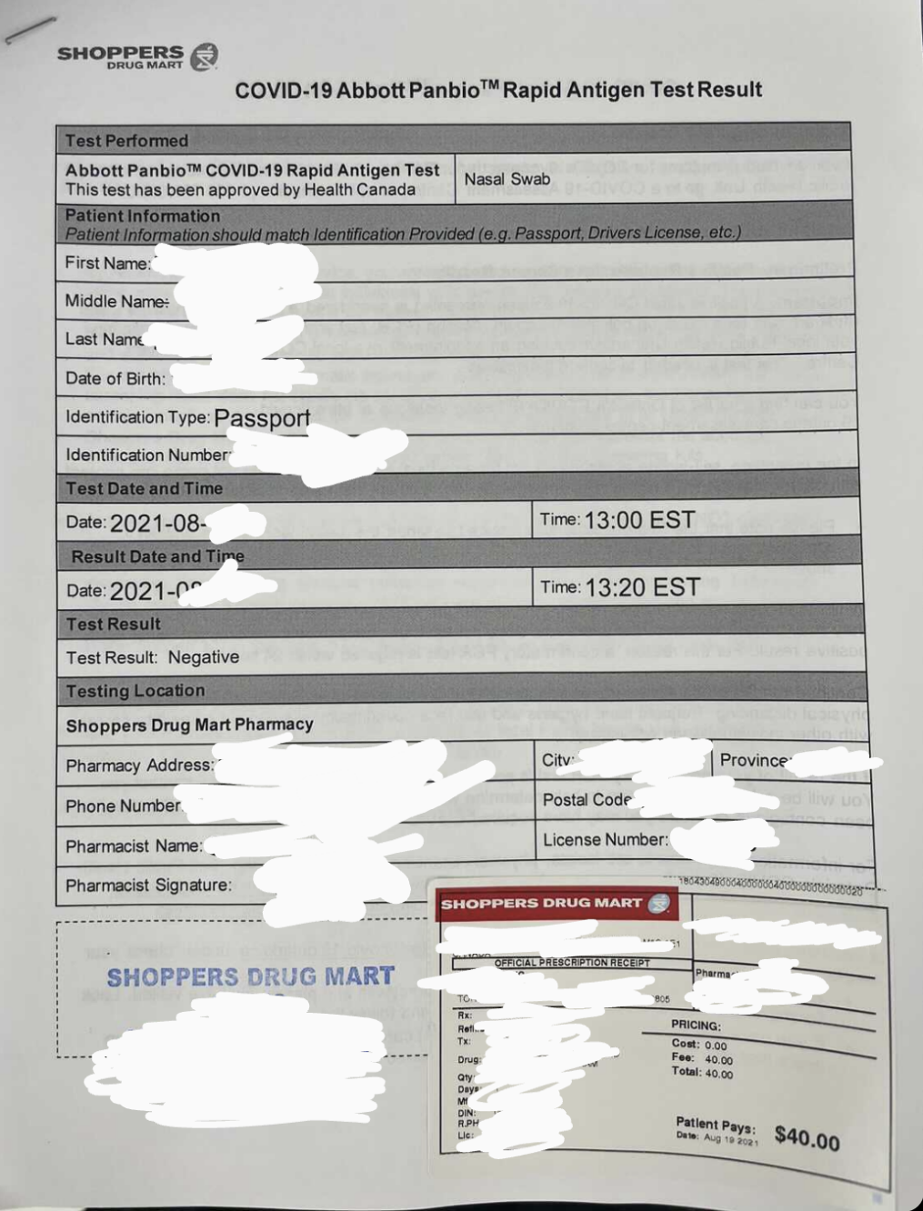

- How do I verify someone’s age if they are under 18 and don’t have a drivers license? The province has indicated that a student ID with a photo would be considered acceptable if no other identification was available.
- Do people have to wear masks inside?
Yes, in accordance to the public health orders, all individuals over the age of 5 must wear a mask indoors regardless of their immunization status.
There are a couple of exceptions to this and they are:
- A person who has a medical condition that is unrelated to COVID 19 including breathing or cognititive difficulties or a disability that prevents them from safely wearing a mask
- A person who is unable to put on or remove a mask without the assistance of another person
- A person who is swimming or engages in other athletic ativities, including referees and other game officials
- A musican or other performer at a licensed premises or at a performing arts venue or announcer or broadcaster at a sporting event.
There are times when a mask can be temporarily removed:
- Receiving a service that requires the removal of their mask
- Consuming food or drink
- Emergency medical purposes
- Establishing their identity

- Can they take their mask off while they are eating or drinking?
Only for the few moments it takes an individual to remove their mask to take a drink or eat can the mask be removed.
- What if they are sitting in the restaurant portion of the arena/building and eating?
As long as they are sitting in the restaurant area of the building and are seated at a table, they can remove their masks while eating and drinking.
- What happens if they refuse to keep their mask on?
Remind them that they must do so and if they refuse, they can be asked to leave. If they refuse, contact your local bylaw, public health or police enforcment agency.
- What is an acceptable mask?
A mask must cover their mouth, nose and chin without gapping.
- Can a face shield be worn without a mask?
No, if a face shield is worn, a mask must also be worn.
- What does a medical exemption look like?
A medical exemption can only be issued by the Province of Manitoba. A doctor’s note is not an authorized medical exemption.

APPENDIX A – PROVINCIAL IMMUMIZATION SAMPLES
